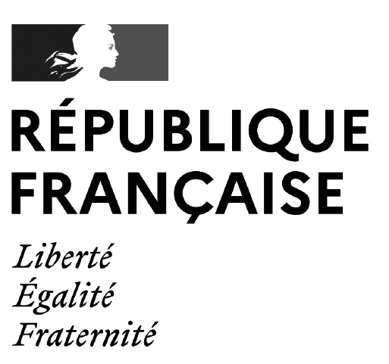

Offre de thèse avec contrat doctoral. Université de Caen Normandie
The discourse on the suffering body in the correspondence of the humanists Erasmus of Rotterdam, Thomas More and John Colet.
Job information
 | Organisation / Entreprise | Université de Caen Normandie
 | Research Field | SHS
 | Researcher Profile | First Stage Researcher (R1)
 | Country | France
 | Application Deadline | 31/05/2024
 | Type of Contract | Temporary (3 years), from october 2024
 | Job Status | Full time
 | Is the Job funded through the UE Research Framework Programme ? | NO
 | Is the Job related to staff position within a Research Infrastructure ? | NO
Offer description
 | Doctoral project description | "Mais de chez vous on ne m’envoie même pas de lettres alors que j’ai survécu à tant de maladies": the discourse on the suffering body in the correspondence of the humanists Erasmus of Rotterdam, Thomas More and John Colet.  The year 1485 saw the rise of the Tudor dynasty but, in England, this political transition also coincided with the development of humanism. The study of ancient sources, particularly those of Galen and Hippocrates, encouraged the development of a new kind of medicine. In many respects, however, and above all in terms of material and health conditions, Tudor society remained very similar to what it had been in the Middle Ages. Cold, hunger, misery and war were ubiquitous. Life in the 16th century was a source of uncertainty and hardship for everyone, peasants, and lords alike. Epidemics (such as the plague and the sweating sickness) were frequent, equally decimating towns and countryside, while syphilis made its debut on the continent. The human body was therefore under the constant threat of disease and the elements.  It should come as no surprise, then, that the suffering body features so prominently in the works and correspondence of these humanists. The precariousness of human life in early modern times - and, more generally speaking, the precariousness of human life in itself – takes pride of place in the correspondence of the Oxford Reformers, John Colet, Erasmus of Rotterdam and Thomas More. Yet their works, and in particular their correspondence, have never before been studied through the prism of the discourse on the suffering body or the medical humanities.  It is this gap that this research project will aim at addressing. It aims to analyse the discourse on the suffering body in the correspondences of these three humanists in early modern England. What place does the suffering body occupy? How does the assiduous reading of classical texts influence the way one thinks about illness? How does this constant reference to ancient thought, so characteristic of humanism, affect one's relationship to the suffering body? Finally, early Tudor England was also the cradle of the English Reformation. This study of the discourse on the suffering body will need to constantly integrate the spiritual and religious background and the natural element of death which is the dreaded horizon of any discourse on illness.
 | Salary placement | 2100-2300 € / month
Requirements
 | Admission requirements | Holding a Master’s Degree
 | Eligibility | Subject to the acceptance of the head of the institution, on the proposal of the ED director after consultation with the director of the research team and the thesis director
Application
A complete application must contain :

- A personal letter with a brief description of your research interests and motivation

- A curriculum vitae (CV)

- Certified copies of grades, diplomas, and documentation of completed academic courses

- Contact information for two references

Work location |  | Université de Caen (Normandy, France)
Where to apply |  | ed558.nh@unicaen.fr
Contact |  | mickael.popelard@unicaen.fr

